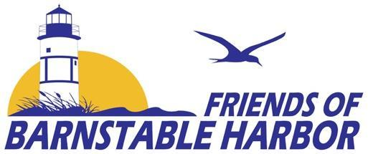

The Friends of Barnstable Harbor Strategic Plan
recognizes that the ecological well-being of harbor ecosystems is threatened by development, climate change, and an exploitation of its resources.

We will utilize science-based projects, education, community outreach, and stakeholder collaboration as essential tools to cultivate knowledge and awareness in our effort to preserve and protect Barnstable Harbor.

We acknowledge that a Strategic Plan is really a Strategic Intention and must be adaptable and fluid in to be flexible in the face of change.

Our goal is for current and future generations to enjoy the harbor’s bounty and its beauty.

Friends of Barnstable Harbor’s core mission is the preservation and protection of Barnstable Harbor, surrounding estuaries and salt marshes, and the barrier beach (Sandy Neck) that protects the harbor. Education, community outreach, and collaboration with like-minded groups and stakeholders will be employed in accomplishing these goals.

FBH will cultivate environmental awareness by offering educational programs and developing studies and projects utilizing science-based tools and principles to foster a stronger connection and understanding between the harbor community and the harbor ecosystem.

- Establish a credible understanding of the biodiversity of the area and advocate for sensible habitat protection and fisheries management.

- Develop an understanding of coastal processes while advocating for sensible protection.

- Identify and monitor projects and activities that have the potential to adversely or positively impact the harbor environment and community character.

FBH will advocate for both recreational and commercial access that encourages waterways safety and navigation while protecting the natural, cultural and historic resources of the harbor. This approach is to ensure that there is a long-term sustainable balance between users and conservation of these resources.

FBH will emerge as a leading resource of the harbor and environs. We will gather cultural history and environmental studies completed for the area.

FBH is an all-volunteer and member driven organization that relies upon the vitality, participation, and the financial support of its membership.

_____________________________________________________________________

Education & Community Outreach:

FBH believes education (both adult & youth) are integral to the understanding of the harbor and preservation of its resources. This will be accomplished through events, free lectures, boat tours, outdoor classrooms, newsletters, website, and social media.

- Youth Education Program -yep! will offer field trips to students and summer youth groups. These trips provide an opportunity for students to experience the harbor and marsh environments, hear about its maritime traditions and history, as well as learn about job opportunities in the natural sciences and blue economy.

- Educational Programs: Future plans include an Outdoor Classroom/On-the-Water Education Center:

  - Harbor tours will focus on history and sustainable harbor resources
  - Hands-on Student Science Lab
  - Develop curriculum based on Benthic Habitat Mapping Project

__________________________________________________________________

Collaboration:

FBH will identify and collaborate with groups and stakeholders interested in the effective management of the harbor, and environs.

State of the Harbor: We will collaborate with other groups and stakeholders to host a biennial State of Harbor event. Each event will address a specific topic pertinent to Barnstable Harbor.

__________________________________________________________________

Cultural History:

Harbor Histories:
An area on our website that honors the harbor’s history and its legends. We will include stories told by, or about, the people who have lived, worked, and/or played upon the waters of Barnstable Harbor.

__________________________________________________________________

Membership & Fundraising:

All-Volunteer and Member Driven Organization:
We will rely upon our membership for our existence. Membership is free and established by our newsletter email list. Members will be encouraged to support FBH through donations, volunteering, and/or by participating in FBH events.

Fundraising is essential to support the projects, programs, and future endeavors of the organization.

